PRN – 260245920034

- Count total no. of employees.
mysql> select count(*) as TotalEmployees from emp;
+----------------+
| TotalEmployees |
+----------------+
| 30 |
+----------------+
1 row in set (0.00 sec)

- Determine the maximum and minimum salary.
mysql> select max(sal) as MaximumSalary, min(sal) as MinimumSalary from emp;
+---------------+---------------+
| MaximumSalary | MinimumSalary |
+---------------+---------------+
| 5000 | 800 |
+---------------+---------------+
1 row in set (0.00 sec)

- Display the count of employees having salary greater than 3000.
mysql> select count(*) as NumEmployees
-> from emp
-> where sal > 3000;
+--------------+
| NumEmployees |
+--------------+
| 4 |
+--------------+
1 row in set (0.00 sec)

- Print department wise count of employees.
mysql> select d.deptno, d.dname, count(e.empno) as NumEmployees
from dept d
left join emp e on d.deptno = e.deptno
group by d.deptno, d.dname;
+--------+------------+--------------+
| deptno | dname | NumEmployees |
+--------+------------+--------------+
| 10 | ACCOUNTING | 5 |
| 20 | RESEARCH | 8 |
| 30 | SALES | 12 |
| 40 | OPERATIONS | 0 |
| 50 | HR | 3 |
| 60 | IT | 2 |
+--------+------------+--------------+
6 rows in set (0.00 sec)

- Display employee details who earn maximum and minimum salary.
-- Employees with Maximum Salary
mysql> select * from emp where sal = (select max(sal) from emp);
-- Employees with Minimum Salary
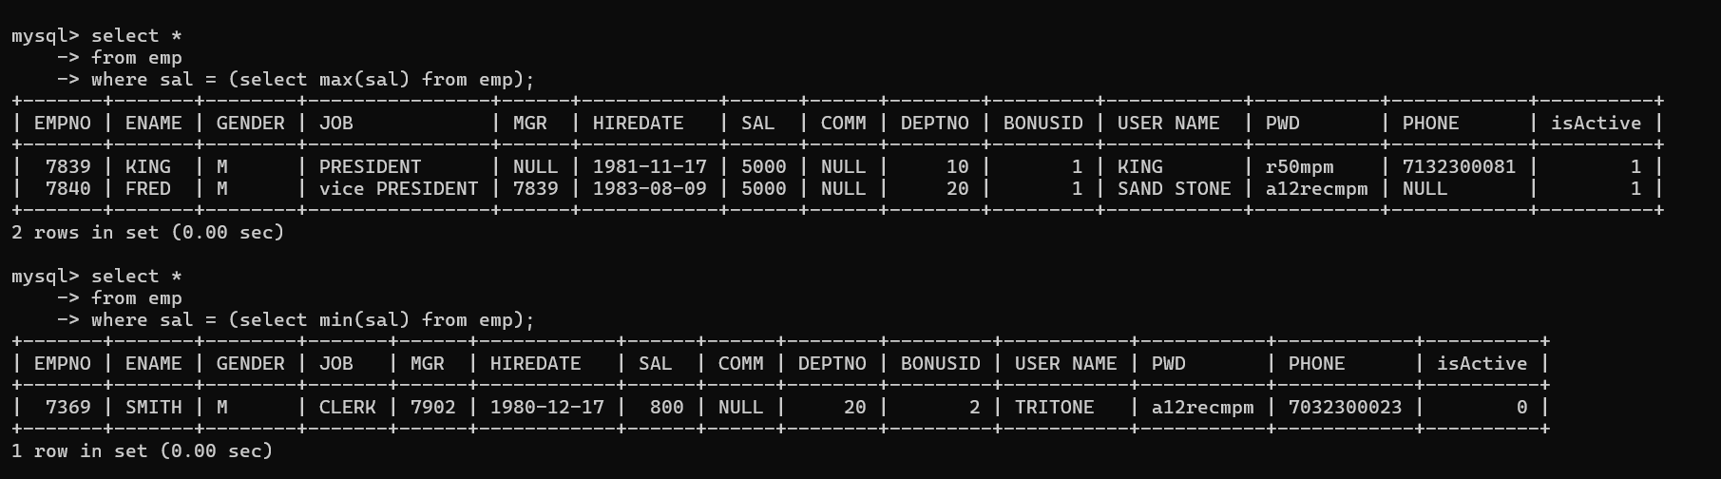
mysql> select * from emp where sal = (select min(sal) from emp);

- Print jobwise total salary.
mysql> select job, sum(sal) as TotalSalary from emp group by job;
+---------------------+-------------+
| job | TotalSalary |
+---------------------+-------------+
| Compliance officers | 5250 |
| Public Relation | 3500 |
| CLERK | 11000 |
| SALESMAN | 9525 |
| MANAGER | 13675 |
| ANALYST | 7750 |
| PRESIDENT | 5000 |
| vice PRESIDENT | 6000 |
| Network | 2000 |
+---------------------+-------------+
9 rows in set (0.00 sec)

- Print department wise maximum salary.
mysql> select deptno, max(sal) as MaxSalary from emp group by deptno;
+--------+-----------+
| deptno | MaxSalary |
+--------+-----------+
| 10 | 5000 |
| 20 | 5000 |
| 30 | 4150 |
| 50 | 1750 |
| 60 | 2000 |
+--------+-----------+
5 rows in set (0.00 sec)

- Print jobwise average salary.
mysql> select job, avg(sal) as AvgSalary from emp group by job;
+---------------------+-----------+
| job | AvgSalary |
+---------------------+-----------+
| Compliance officers | 1750.0000 |
| Public Relation | 1750.0000 |
| CLERK | 1571.4286 |
| SALESMAN | 1587.5000 |
| MANAGER | 2735.0000 |
| ANALYST | 2583.3333 |
| PRESIDENT | 5000.0000 |
| vice PRESIDENT | 3000.0000 |
| Network | 2000.0000 |
+---------------------+-----------+
9 rows in set (0.00 sec)

- Print count of employee working in department 20.
mysql> select count(*) as NumEmployees from emp where deptno = 20;
+---------------------+
| NumEmployees |
+--------------------+
| 8 |
+-------------------+
1 row in set (0.02 sec)

- Print count of employee working in department 10 having job as MANAGER..
mysql> select count(*) as NumEmployees from emp where deptno = 10 and job = 'MANAGER';
+---------------------+
| NumEmployees |
+--------------------+
| 1 |
+-------------------+
1 row in set (0.04 sec)

- Print count of employee working in department 20 having comm as null.
mysql> select count(*) as NumEmployees from emp where deptno = 20 and comm is null;
+---------------------+
| NumEmployees |
+--------------------+
| 8 |
+-------------------+
1 row in set (0.03 sec)

- Print names of employees working in ACCOUNTS department having maximum salary.
mysql> select ename, sal from emp where deptno = (select deptno from dept where dname = 'ACCOUNTING') and sal = (select max(sal) from emp where deptno = (select deptno from dept where dname = 'ACCOUNTING'));
+-------+------+
| ename | sal |
+-------+------+
| KING | 5000 |
+-------+------+
1 row in set (0.00 sec)

- Print employee details having salary less than average salary of MANAGER.
- Give SQL statement to find the average annual salary per job in each detp.
- Count the number of people in the dept 30 who receive a salary and the no.of people who receive comm.
- Calculate the avg, min and max salary of those groups of employees having the job as CLERK or MANAGER.
- Display the deptno of departments which have more than one CLERK.
- List names and hiredates of employees who were hired in the month of December
- List names and hiredate of employees hired in the year 1980
- Display names and jobs of the people separated by a hyphen. Capitalize the first character of name and job.
- List employee numbers, names and hiredates of the people working in the department number 20, display the hiredates in the dd/mm/yy format
- Find number of months the president has worked for the company.
- Find the day of the week on which SMITH joined
- Find the time of time of the day in which ADAMS joined
- Find day of month on which KING joined
- Find out month on which MARTIN joined
- Find out which quarter of the year the employees joined. Display their number and names as well
- Retrieve ANALYST records with the hiredate formatted as – ‘The 3rd of December 1984’
- List all names, jobs, and a job classification number, which is to be assigned by you. Translate the value started in each job field to a job classification number.
This is to be done as follows-
A. CLERK
B. MANAGER
C. PRESIDENT
D. OTHER
- Display the length of the longest employees name
- Write a query to list the length of service of the employees (of the form n years and m months).
- How many employees who are joined in 1985.
- How many employees joined each month in 1985.
- How many employees who are joined in March 1985.

- Find the total sales amount

- Find the customer-wise lowest and highest sales amount
- Find product-wise lowest, highest and total sales.
- Find department-wise average salary for all the departments employing more than three employees
- Find the customer-wise total sales for all the customers except ‘TKB SPORT SHOP’ who came to purchase various sports items maximum four times.
- Display the highest, lowest, sum and average salary for all employees. Label the columns appropriately.
- Modify the above query and display the output for each job type.
- List names of people who have salary less than the average salary for dept 20
- Find the average annual salary per job in each department.
- Count the number of people in department 30 who receive a salary and the number of people who receive a commission
- Compute the average, minimum and maximum salaries of these groups of employees having job as Clerk or manager, Display the job as well
- Write an SQL command that displays 2nd highest salary paid
- Write a query to find the employees who are earning the maximum salary in their departments.
- Write a query to find the salesman number (repid) who has achieved the maximum total sales among the entire salesman.
- List the highest salary paid for each job.
- Find the most recently hired employee in each department.
- In which year did most people join the company? Display the year and the number of employees.
- Write a query to display employee name whose name occurs only once in the table.
- Write a query to display all the details from dept table along with the no. of employee working in each dept.
- Find out which department does not have any employees.
- List out the no. of employees joined in every month in ascending order.

